Report: Data Science Job Salaries Analysis
- Objective
This Python script is designed to preprocess, analyze, and visualize a dataset containing data science job salaries. It aims to uncover insights regarding salary distribution and how salaries are influenced by factors like experience level, job type, employment type, company size, and geographical location.
- Code Walkthrough
1. Importing Libraries
Essential libraries are imported for handling data preprocessing, visualization, and country name conversion.
Python:
import pandas as pd
import matplotlib.pyplot as plt
import seaborn as sns
import country_converter as cc
2. Loading the Dataset
The dataset is loaded from the specified file path using pandas. Users must replace the placeholder path with the actual path on their system.
Python:
file_path = "C:/Users/Sanika/Downloads/Data Science Job Salaries.csv"
data = pd.read_csv(file_path)
3. Standardizing Country Names
Abbreviations in the company_location and employee_residence columns are converted to full country names for better readability and consistency.
Python:
cc = cc.CountryConverter()
data['company_location'] = cc.convert(data['company_location'], to='name_short')
data['employee_residence'] = cc.convert(data['employee_residence'], to='name_short')

4. Renaming and Mapping Job Types
The remote_ratio column is renamed to job_type. Numeric codes (100, 50, 0) are mapped to descriptive categories (remote, hybrid, and onsite).
Python:
data.rename(columns={'remote_ratio': 'job_type'}, inplace=True)
data['job_type'] = data['job_type'].map({100: 'remote', 0: 'onsite', 50: 'hybrid'})
5. Quick Data Inspection
The first few rows of the dataset are displayed to verify that it has been loaded and processed correctly.
Python:
print(data.head())
6. Data Analysis and Visualizations
Salary Distribution
A histogram is used to visualize the distribution of salaries with a kernel density estimate overlay.
Python:
plt.figure(figsize=(10, 5))
sns.histplot(data['salary'], bins=30, kde=True)
plt.title('Salary Distribution', fontsize=16)
plt.xlabel('Salary')
plt.ylabel('Frequency')
plt.show()
Mean Salary vs. Experience Level
The relationship between mean salary and experience level is analyzed using a bar plot.
Python:
mean_salary_exp_level = data.groupby('experience_level')['salary'].mean()
plt.figure(figsize=(12, 6))
sns.barplot(x=mean_salary_exp_level.index, y=mean_salary_exp_level.values, palette='spring')
plt.title('Mean Salary vs Experience Level', fontsize=16)
plt.xlabel('Experience Level')
plt.ylabel('Mean Salary')
plt.show()
Employment Type vs. Salary
A bar plot highlights differences in mean salaries for different employment types (e.g., full-time, part-time, contract).
Python:
mean_salary_emp_type = data.groupby('employment_type')['salary'].mean()
plt.figure(figsize=(12, 6))
sns.barplot(x=mean_salary_emp_type.index, y=mean_salary_emp_type.values, palette='autumn')
plt.title('Mean Salary vs Employment Type', fontsize=16)
plt.xlabel('Employment Type')
plt.ylabel('Mean Salary')
plt.show()
Company Size vs. Salary
The effect of company size on mean salary is examined and visualized.
Python:
mean_salary_company_size = data.groupby('company_size')['salary'].mean()
plt.figure(figsize=(12, 6))
sns.barplot(x=mean_salary_company_size.index, y=mean_salary_company_size.values, palette='spring')
plt.title('Mean Salary vs Company Size', fontsize=16)
plt.xlabel('Company Size')
plt.ylabel('Mean Salary')
plt.show()

Job Type vs. Salary
The average salary for each job type (remote, onsite, hybrid) is compared.
Python:
mean_salary_job_type = data.groupby('job_type')['salary'].mean()
plt.figure(figsize=(12, 6))
sns.barplot(x=mean_salary_job_type.index, y=mean_salary_job_type.values, palette='Set2')
plt.title('Mean Salary vs Job Type', fontsize=16)
plt.xlabel('Job Type')
plt.ylabel('Mean Salary')
plt.show()
Top 10 Data Science Roles by Mean Salary
The top 10 data science roles by mean salary are identified and visualized.
Python:
top_roles_by_salary = data.groupby('job_title')['salary'].mean().sort_values(ascending=False).head(10)
plt.figure(figsize=(14, 6))
sns.barplot(y=top_roles_by_salary.index, x=top_roles_by_salary.values, palette='Set2')
plt.title('Top 10 Data Science Roles by Mean Salary', fontsize=16)
plt.xlabel('Mean Salary')
plt.ylabel('Job Title')
plt.show()
Top 10 Countries by Mean Salary
The top 10 countries with the highest mean salaries are displayed for insights into geographical salary variations.
Python:
top_countries_by_salary = data.groupby('company_location')['salary'].mean().sort_values(ascending=False).head(10)
plt.figure(figsize=(14, 6))
sns.barplot(y=top_countries_by_salary.index, x=top_countries_by_salary.values, palette='Set2')
plt.title('Top 10 Countries by Mean Salary', fontsize=16)
plt.xlabel('Mean Salary')
plt.ylabel('Country')
plt.show()
- OUTPUT:
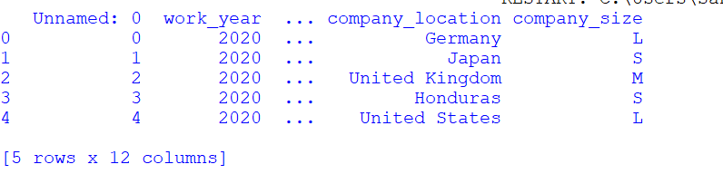

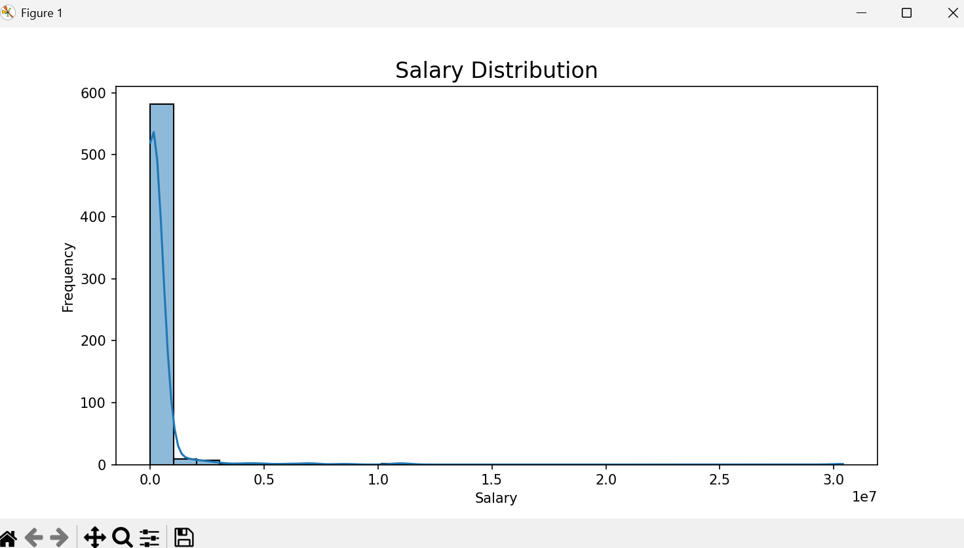
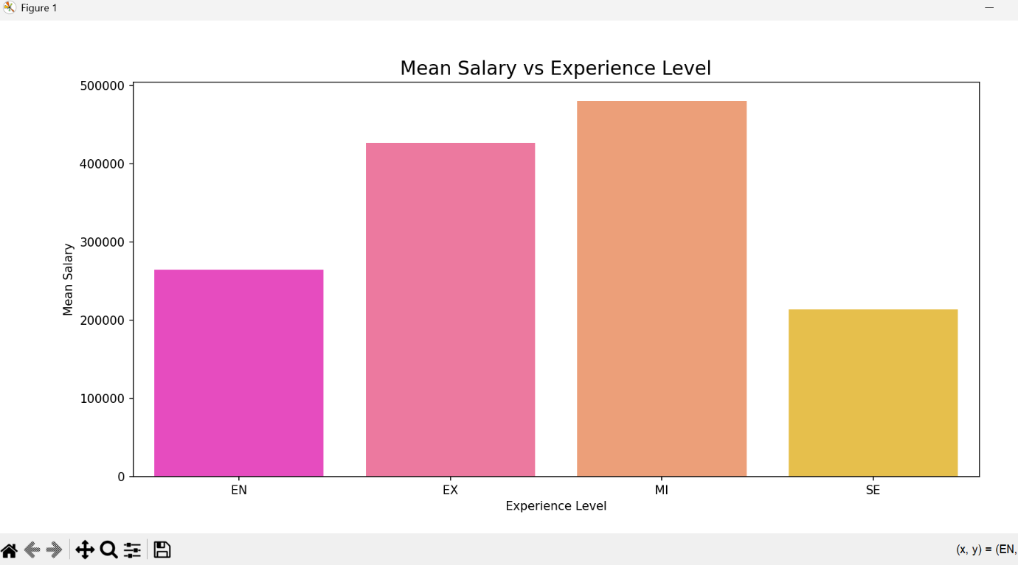
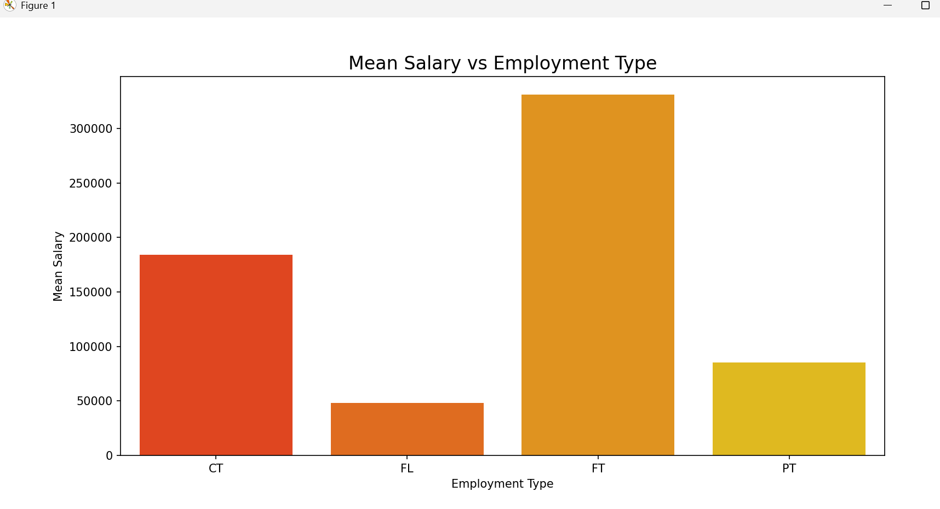
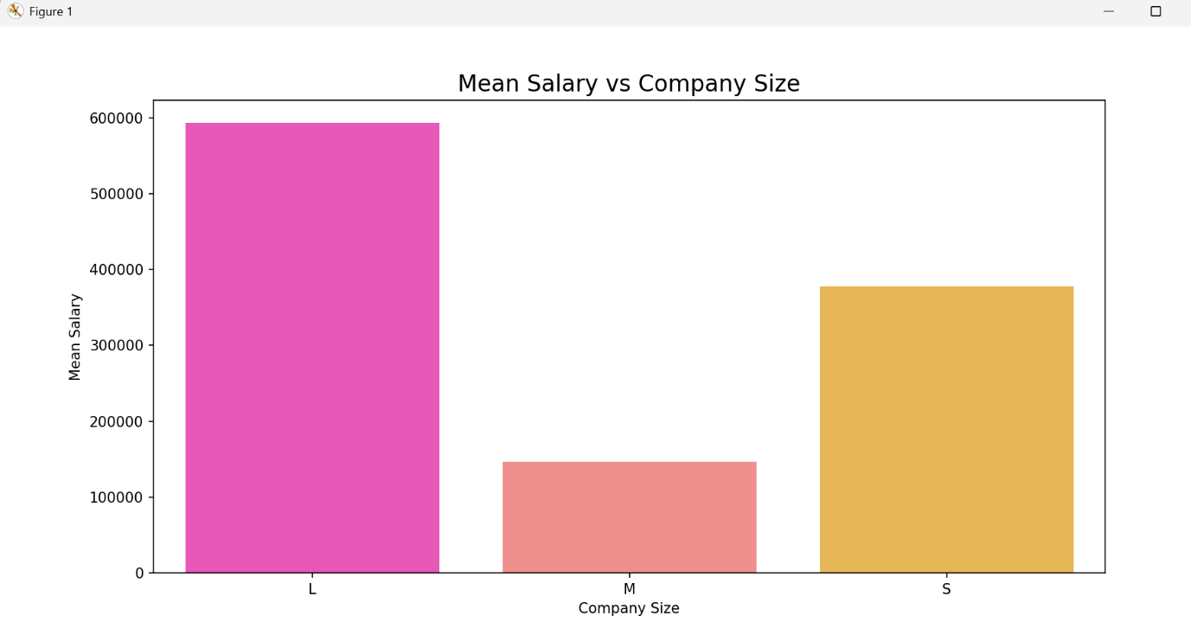
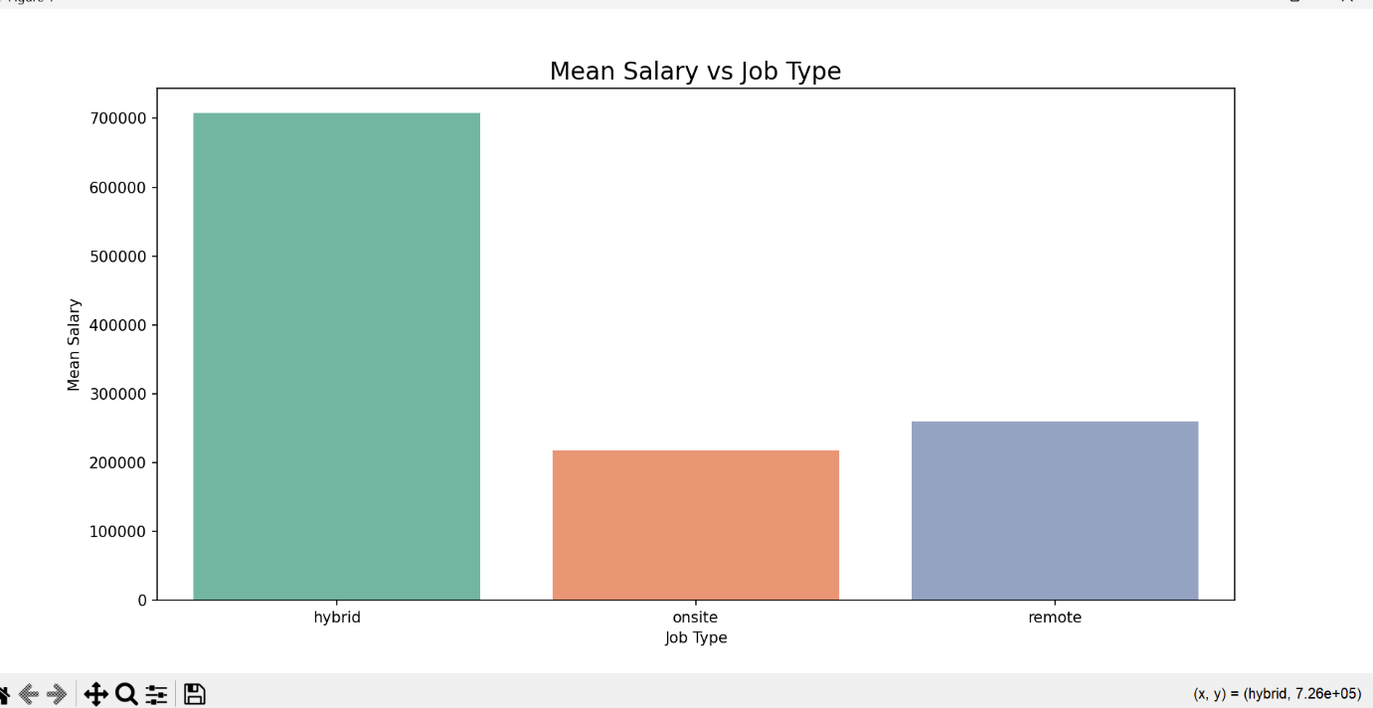
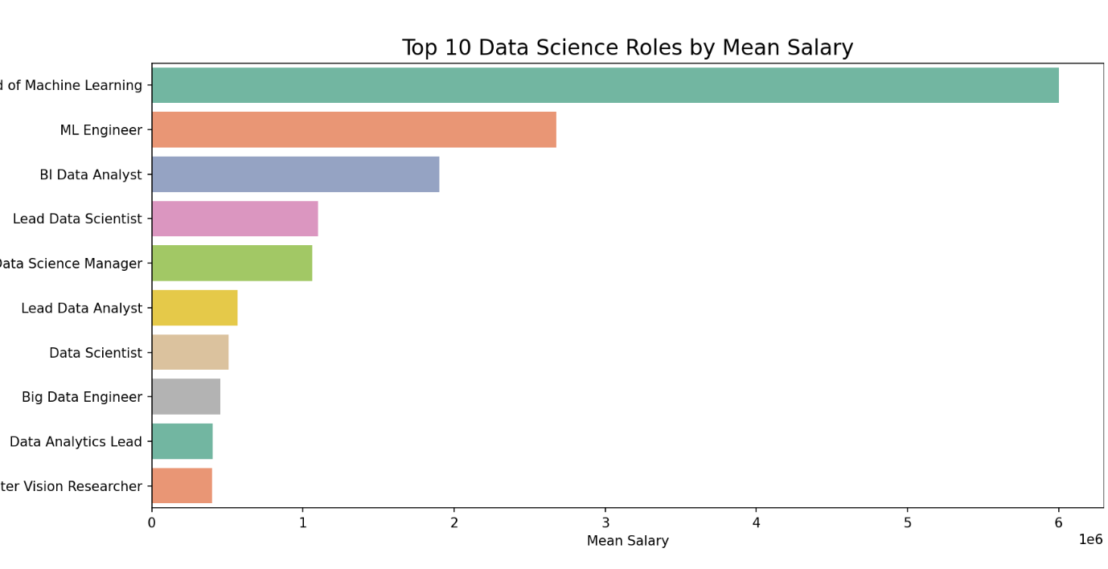
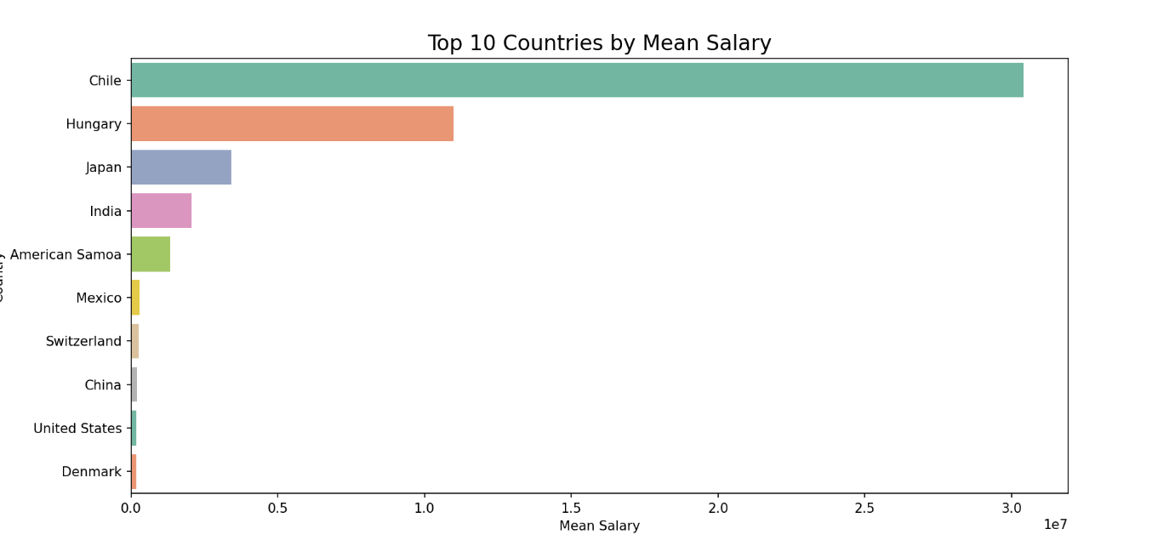

- Problem-Solving and Challenges
1. Standardizing Country Names
- Problem: Country abbreviations were hard to interpret.
- Solution: Used country_converter to replace abbreviations with full country names.
2. Job Type Mapping
- Problem: Numeric job type codes were unclear.
- Solution: Replaced numeric codes with meaningful labels like remote, onsite, and hybrid.
3. Handling Data Visualization
- Problem: Complex relationships required appropriate visualizations.
- Solution: Bar plots were used for categorical data, and histograms with KDE for distribution.
4. Large Categories
- Problem: Data with a large number of unique categories (e.g., job titles) made visualizations cluttered.
- Solution: Focused on the top 10 categories for clarity.
5. File Path Issues
- Problem: File paths need to be explicitly specified by users.
- Solution: Provided guidance for replacing placeholder paths with actual file locations.
- Conclusion
This code successfully preprocesses and analyzes the dataset to provide meaningful insights into salary trends in the data science field. Challenges were resolved using robust data manipulation and visualization techniques, making the analysis both effective and insightful. For further enhancement, advanced machine learning models could be implemented to predict salaries based on input features

